User guide
for the OpticalTweezers GitHub repository
The Matlab files in the repository https://github.com/are-mj/OpticalTweezers address two main tasks:
- Finding and quantifying unfolding and refolding events (rips and zips) in recorded time series from protein stretching and relaxing experiments. The results are presented in Matlab tables with one row for each event.
- Fitting models to the result tables from task 2. This part will be added later.

Finding rip and zip events in experiment files

Organising experiment files
I prefer to store related experiment files in one data folder, separated into subfolders denoting experiment date or some other characteristic. I specify the data folder in the function datafolder, which returns the data folder path. Then I can uniquely specify the experiment by the subfolder name and file name.
Example:
Data folder: “C:/Users/are/OneDrive/Data/Chile/Top7”
File name: “20251029/dA.txt”

MS Windows uses backslash (\) instead of slash (/). Most functions in the repository automatically replace backslash with slash when needed, for consistency between Windows and Unix.

Experiment files generated by the Mini Tweezers instrument by Steven B. Smith Engineering, Los Lunas, New Mexico should also contain a COM file containing more details about the experiment, such as bath temperature. These are automatically read if they exist.

Experiment files from other sources may require modifications to the function read_experiment_file.

Analysing an experiment file
This is done by function analyse_experiment. Typical use:
[Trip,Tzip] = analyse_experiment(“20251029/dA.txt”,1,par);
The second input parameter tells the function to create a time series plot of the pulling force, with rips and zips. If this is missing or set to 0, no plot is produced. Trip and Tzip are Matlab tables with one row per rip or zip, containing details such as rip time. The columns in Trip and Tzip are given in the paragraph on create_table.

Options for analyse_experiment
The third input to analyse_experiment, par, must be a struct with fields that specify options, tuning parameters and other information to control how the function analyses the experiment data. The main options are:
maxrips | The maximum number of rips (or zips) that will be recognised per trace
laterips | Return maximum one rip that happens in the relaxing trace

maxrips specify the number of rips /zips that will be reported, sorted by force step. If laterips is false, late trips will not be reported. Regrettably, no models in the repository are currently able to exploit the results of other options than maxrips = 1, laterips = 0.
The par input is optional. If missing, the function will try to read function params.m. If neither the third input nor this file exists, an error will result.
For details about how analyse_experiment performs its analysis, see the function description in the chapter on Matlab functions for finding and quantifying rips ad zips.

The RipAnalysis app
The analyse_experiment function is good at finding rips and zips if the experiment results are clear and unambiguous. However, this is not always the case. Measurement noise or weak responses to the events may confuse the algorithm. Sometimes events are easier to spot by visual inspection. The RipAnalysis app lets the user inspect results of analyse_experiment in detail and to remove or add rips or zips that were not detected correctly. To start the app, right-click RipAnalysis.mlapp and select Run. Alternatively, select Open then click the “Run” button in the “Designer” tool strip. For first time use this will open the window below, but with no data. Paste the path to the relevant data folder in the text box labelled ‘Data folder’. The ‘output folder’ text box will get the same text. Change this only if you want to store the corrections in a special folder. Next, paste the name of an experiment file in the ‘Data file’ text box. You may also use the ‘Select xxx’ buttons, but pasting is usually quicker.
NOTE: I have saved all files from Matlab R2024b. Backwards compatibility is not perfect for apps. Thus, if you modify the app using a newer version it may not work properly under the older version. This is a potential problem only if you collaborate with someone who uses an older Matlab version than yours.
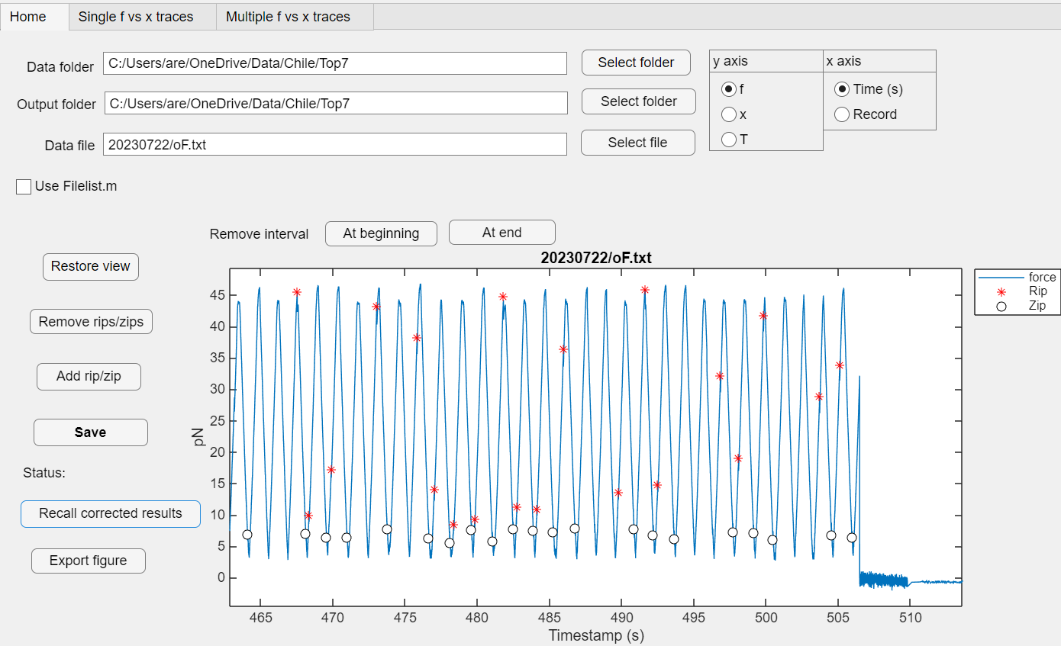
Figure 1; Home screen
When the data file name is in place, the app starts function analyse_experiment and displays the output in the axes area. (NOTE: You cannot use the ‘Enter’ key on your keyboard. Just click in some unoccupied space in the app window.)
At the upper right you can choose between showing the pulling force f, the trap position x or the temperature T. You can also use the record number in the file instead of time on the horizontal axis.

Modifying results
You can remove irrelevant data from the start or end of the time series by clicking the buttons above the axes. This will bring up a pair of cross hairs. Only the x position of the cross hairs is used.
The Remove rip/zips button presents a list of all rips and zips visible in the figure. Zoom in first if many rips/zips are visible.
The ‘Add rip/zip’ button lets you place new events using cross hairs. Please zoom in first for better accuracy.
The Save button saves a *.mat file with the same name as the data file in the output folder. This file contains the output files Trip and Tzip from analyse-experiment, with any modifications you have made. It also contains a variable ‘limits’ giving the start and end of the valid time series. NOTE that this does not affect the original data file. You can read in the original data and repeat the automatic analysis by clicking the ‘Revert to automatic analysis’. If the text of this button is “Recall corrected results” this will recall the last saved results.

Plot force vs. trap position
The analyse_experiment function fits straight lines to the force vs x graph to analyse all rips and zips. The ‘Single f vs, x traces’ tab at the top of the screen brings up a window where you can inspect this in detail in this window:
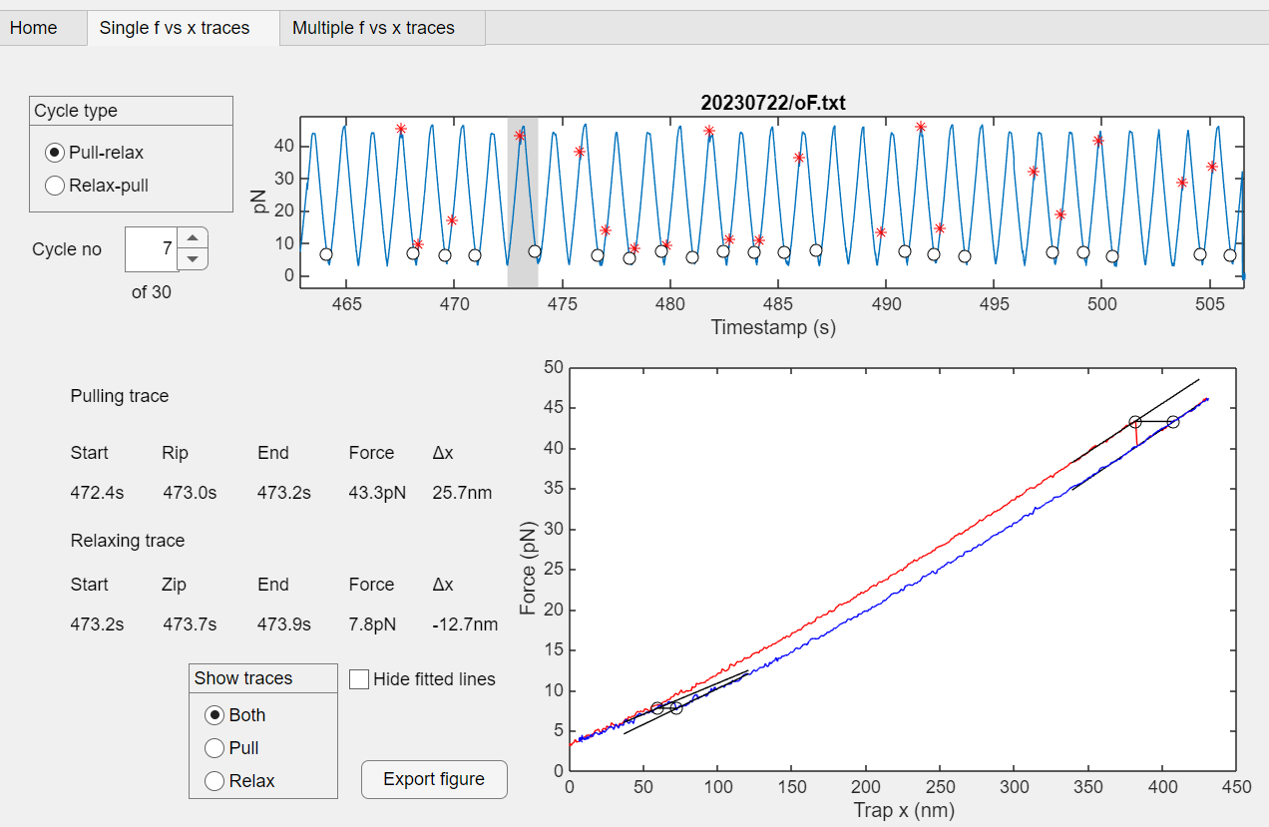
The upper figure shows the same graph as the ‘Home’ screen. The ‘Cycle no’ spinner lets you select the relevant cycle. Use the up and down arrow or type in the cycle number. The lower figure displays a graph of single a single pull-relax or relax-pull cycle, with fitted lines before and after the rip and zip, The pulling trace is in red. Data for the current cycle are shown to the left. In both figures you can zoom and pan. You can also hide one of the traces and the fitted lines.
The ‘Export figure’ button copies the graph in the lower axes to a separate figure window. Here, after zooming and hiding the relaxing trace:
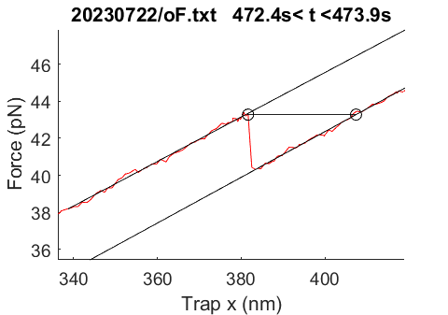

The length of the horizontal line is Δx and the vertical line is the force shift.

The ‘Multiple f vs. x traces window lets you see several cycles in the same plot:
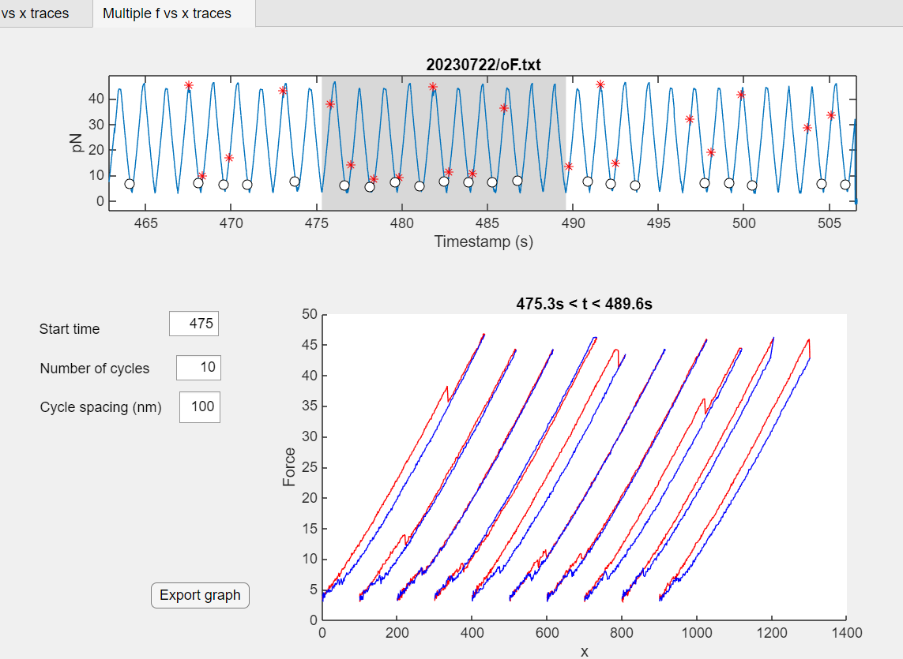
The ‘Cycle spacing’ input determines the horizontal spacing between the traces in the plot. Pulling traces are in red, relaxing traces in blue. The red and blue traces do not always match at the top. This is an artefact of the preprocessing, where all traces are shifted so that x = 0 at the bottom of all valleys, to compensate for drift in the measurements. Note that the last trace clearly shows a zip that was not recognised by the automatic analysis and so is not shown in the upper figure.
When you return to the ‘Home’ window, the force vs. time graph shows only the cycles currently selected. Click the ‘Restore view’ button to show the whole time series.

Analysing many experiment files
If you want to inspect many files, create a function Filelist.m that returns a list of the relevant file names and place it in the data folder. Checking the ‘Use Fielist.m’ box will bring up a spinner which lets you display results for several files in turn: Use the up/down arrows or type in the relevant index.

You can concatenate the results tables for several experiments by functions analyse_many or collect_results.
Both functions take a string array of experiment file names as input. To use the unmodified results of analyse_experiment directly, use:
[TRIP,TZIP] = analyse_many(files);
To use the corrected results stored by the Rip Analysis Matlab app, use:
[TRIP,TZIP] = collect_results(files);
This will use the corrected Trip and Tzip tables where they exist and run analyse_experiment to analyse the rest.
The input files is an array of file name strings, e.g.
files = [“20251029/aA.txt”;“20251029/dA.txt”];
To set the variable files to the list of files in Filelist.m:
thisfolder = pwd; cd(datafolder); files = Filelist; cd(thisfolder)

Utilities
The subfolder ‘Utilities’ contains two helper functions to generate a list of file names to be used with functions analyse_many or collect_results:
files = textfile_names(folders,'nocom');
‘nocom’ tells the function to skip COM files. If the argument is missing, the output contains all *.txt file names. To create a large folder list:
folders = subfolders(datafolder,'numeric');
This returns a list of folder names in datafolder. The last argument tells the function to return only folder names that can be interpreted as a number, e.g. “20230315”.

Fitting models
The aim of protein pulling experiments is to contribute to the understanding of the Mathematical models exist to determine aspects of the unfolding and refolding processes-
To be added.

Matlab functions for finding and quantifying rips ad zips

Main function: analyse_experiment.m
This is the central function for extracting data from experiment results files from the optical tweezers is instrument. It uses several functions to perform its main tasks:
- Read experiment raw data files with time series of time t, trap position x, pulling force f and temperature T (if relevant): read_experiment_file.m .
- Identify pulling and relaxing episodes (traces): peaksandvalleys.m
- Analyse individual pulling or relaxing traces to find and quantify unfolding and refolding events (rips and zips): rip_finder.m and rip_finder_fit.m.
- Create tables of rips and zips with calculated properties of each event: create_table.m.
Syntax:
[Trip,Tzip] = analyse_experiment(file,plotting,parameters);
Inputs:
file: File with recorded experiment results. Usually this is prepended with the output of function datafolder. Alternatively, it may contain the full path to an existing file.
plotting: 1 for a plot of the pulling force time series with rips and zips, 0 or missing: No plot
parameters: Matlab struct with parameters for control and tuning. If missing, the program will try to use the output of params.m

read_experiment_file.m
This function is tailored to read files generated by the Mini Tweezers instrument by Steven B. Smith Engineering, Los Lunas, New Mexico but it can also read simple three column files of time, trap position and force.
For each experiment the Mini Tweezer creates two files:
- A “COM” file containing information about the setup and running of the experiment, most notably the temperature of the bath surrounding the tweezers chamber.
- One or more experiment files containing time series of
  - Time t (or equivalent: Cycle count)
  - Pulling force f
  - Trapped bead position x
  - Status
The status column may contain coded information about extra heating of the chamber. Interpretation of this information must be supplied in the parameters as par.Tlist.
read_experiment_file returns a n by 4 array, where n is the number of lines in the experiment file and the four columns give recoded time (s), pulling force (pN) and trap position (nm). The fourth column shows temperature (°C), if available, otherwise all entries are NaN. The row number in this array is denoted the index.
For other file formats it may be necessary to modify this function.

peaksandvalleys.m
Syntax:
[peakpos,valleypos] = peaksandvalleys(z,threshold,lim);
Input:
z: signal to be analysed (f: pulling force or x: trap position)
threshold, lim: See Figure 3 below
Output:
Peakpos: position (record index) of the identified peaks
Valleypos: position of the valley bottoms.

We want to search every pulling and relaxing trace for rips or zips, respectively. A pulling trace starts when the position of the trapped bead starts to increase and ends when it starts decreasing. Figure 2 shows time series of pulling force and trap position.
A close inspection reveals that the peaks in the force and position time series do not in general happen at quite the same time. This is mainly due to measurement noise. We want to find the peaks and valleys in the x time series. Frequently, however, the drift in x complicates such a direct approach. The force time series, on the other hand, seldom displays significant drift, so the solution is to first find the peaks in the force signal. The record index of the x valley is then given by the index of the minimum x value between two neighbouring force peaks. This lets us remove the drift in x by shifting the x values for each relax-pull cycle so that the minimum x value is zero.
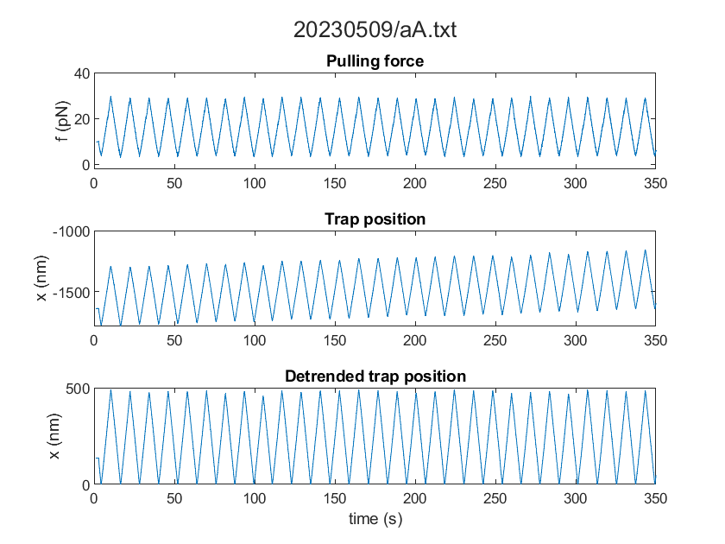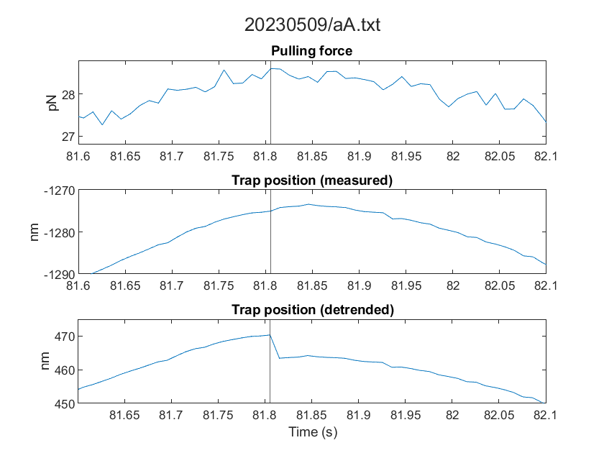
Figure 2: Sample time series for pulling force, measured trap position and detrended trap position. Right-hand panel: details around one peak. If the original x trend is increasing the peak in the detrended trap position will coincide with the force peak. Otherwise, the x peak occurs one record later.
This detrending method has the unfortunate side effect of introducing discontinuities in x at the peak values as shown in Figure 2, but this seldom creates significant problems.
The method used by peaksandvalleys for the pulling force is illustrated in Figure 3.
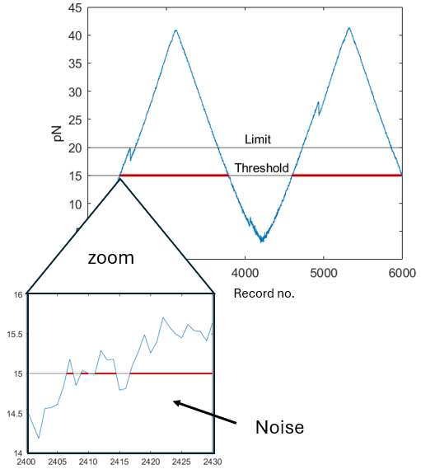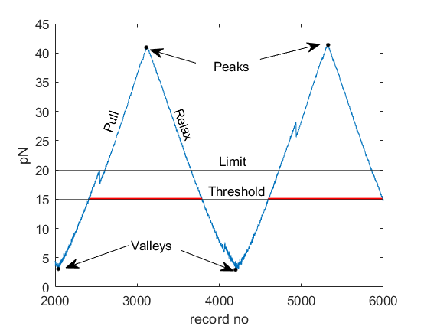
Figure 3: Elimination of noise when finding force peaks and valleys. To eliminate the effect of measurement noise, only intervals where the force exceeds the limit are kept as high force intervals. Peaks are the points of maximum value within a high force interval. Valleys are defined correspondingly.
The function returns peakpos: The record index of the maximum value in a high force interval, and valleypos: The record index of minimum value of f between two high force intervals. This first finds the force peaks and valleys in the recorded force time series.

Next, the function is called with trap position x instead of force f to determine the peak and valley positions.

If the signal is decimated, as discussed in the paragraph decim.m, peaksandvalleys is called once more before detrending, with the decimated pulling force as input, to update the record indices.

We denote the interval between two valleys as a pull-relax cycle. Sometimes the interval between two peaks (a relax-pull cycle) is more relevant. The app lets you select which cycle type to show.

decim.m
If the mean number of records per trace is very high because the recording frequency is very high compared to the pulling velocity, a recorded rip event may span several records and may not be registered as a rip by the algorithm in rip_finder.m. To avoid this situation every time series is decimated by being smoothed and resampled at lower frequency. This keeps keep the mean number of recordings per trace below the parameter maxpointspertrace. Note that peaksandvalleys is rerun on the decimated data.

pull and relax trace structs
A trace struct is a Matlab struct that holds the results from rip_finder for any rips or zips in the trace. Function create_table translates this to one (or more, if par.maxrips > 1) lines in the output tables Trip or Tzip.

rip_finder.m and rip_finder_fit.m
The rip_finder function takes a trace struct as input. For pulling traces it looks for peaks in the negative slope of the force trace. It uses rip_finder_fit to fit straight lines to the force before and after the potential rips and calculate force shift Δf. Rip_finder rejects any candidate with a force shift that is too low compared to the signal noise and selects the remaining candidate(s) that has the largest force shift.
If a valid rip event is found the function calculates the change Δx in trap position and several other data for the rip. These data are added to the pull or relax trace struct.
Relaxing traces are analysed in the same way after reversing the sign of f.

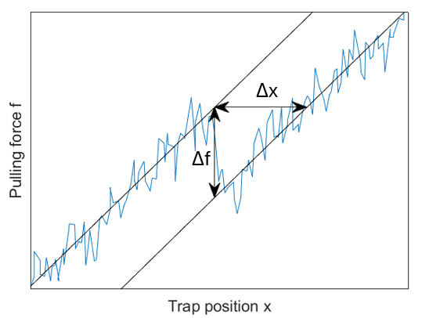
Figure 4: Illustration of the force shift (Δf) and change in trap position (Δx)

create_table.m
Creates a analyse_experiment output tables Trip and Tzip containing details of all identified rips and zips in an experiment file. It takes a pull or relax trace struct as input and creates a Matlab table with one row and the following columns:
Column name | Description
Filename | Name of experiment file
Time | Time stamp of rip or zip (s)
Deltax | Δx as shown in Figure 4 (nm)
Force | Rip force (pN)
Temperature | Temperature (°C)
Forceshift | Δf as shown in Figure 4
Trapx | Position of the trapped bead
Fdot | Pulling force rate of change (pN/s)
Slope_b | Linear fit to f(x): Slope of f(x) before rip (pN/nm)
Offset_b | Linear fit to f(x): Offset before rip (pN)
Slope_a | Linear fit to f(x): Slope of f(x) after rip
Offset_a | Linear fit to f(x): Offset after rip (pN)
Pullingspeed | Rate of pulling; dx/dt (nm/s)
Topforce | Maximum force in cycle
Noise | Standard deviation of (f – smoothed f)
Fitrange | Start and end record numbers used to fit straight lines around a rip/zip
Cycleno | Pull-relax cycle no
Work | Crooks stretching work from zero to rip force (pN nm)
Timestep | Time between records (s)

Analyse_experiment collects these table rows into output tables Trip and Tzip, with one row for each rip/zip.

laterip.m
Rips occasionally happen after the pulling trace is finished, as seen here:
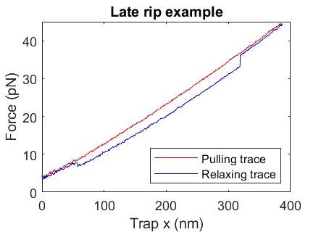
if the parameter laterips = 1, analyse_experiment will check for rips not only in pulling traces, but also in the following relaxing trace. Late rips will be shown in the f vs t graphs and reported in the Trip table. The par.maxrips rips with the larges force shifts will be shown in the f vs t graphs and recorded in the TRIP table.

trim_trace.m
This will remove rips or zips with unlikely variable values. The current version checks only that the deltax value is within the limits set in par.deltaxlimits_rips and par.deltaxlimits_zips.

Functions for creating results for many experiments

analyse_many.m, collect_tables.m
analyse_many takes a list of file names and runs analyse_experiment for each, concatenating the Trip and Tzip output tables into TRIP and TZIP. If you have used the RipAnalysis.mlapp to modify some rips/zips, use collect_tables instead. For experiment file <experiment>.txt it will look for <experiment>.mat in the same folder. This will contain the modified Trip and Tzip tables. collect_tables will use these tables if available. For experiments where the relevant *.mat file does not exist it will call analyse_experiment.

Matlab functions for fitting models
To be added later

